**Brittany Field Trial Hall of Fame**

Rick Smith, Chairman

P.O. Box 130 Crozier, VA 23039

804/784-3882

huntsmithrick@yahoo.com

April 10, 2020

To Brittany Field Trial Hall of Fame Election Committee

ABC Regional Clubs

For those of you who haven’t bought a brick yet, we have an anonymous donor who

will buy $1000 worth of bricks IF we can sell another 10 bricks totaling $l000.

The Brittany group has purchased more bricks than any other breed but there is still

a section of the walkway that needs more bricks. Information and an order form are

attached to this letter.

Not only are individual people buying bricks but clubs are buying bricks too. A list of

bricks already purchased is attached. IF you don’t see yours listed, please let me

know.

**Let’s get 10 more bricks sold soon so the donor will help with this project.**

Thanks in advance for your support,

Rick Smith

**PAVING MEMORY LANE FUNDRAISER**

For the Brittany Endowment Fund

The museum’s newest fundraiser, “Paving Memory Lane,” is ongoing. The museum is offering engraved bricks on which you can immortalize your dog or a person that you feel should be honored or remembered. Your bricks will be grouped and laid permanently with other Brittany bricks in the walkway.

The bricks can have up to three lines of text with up to 15 characters per line. These bricks will be used to create a memorial walk from the museum’s parking lot to the front door. The cost is $100.00 per brick with a portion paying for the brick and the rest going into the Brittany Endowment Fund.

The bricks can be ordered three different ways:

BY MAIL: The following page is the order form for the bricks, to be filled out and mailed to the museum with a check or money order to the following address:

The Bird Dog Foundation, P.O. Box 774, Grand Junction, TN 38039

BY PHONE: To place a phone order, call the museum at (731)764-2058 and provide the necessary information and a credit card number.

INTERNET VIA PAYPAL: Log onto the museum’s website at [*www.birddogfoundation.com*](http://www.birddogfoundation.com), click on the Paving Memory Lane brick and enter the required information.

*Indicate* ***“Brittany Fund”*** *on your payment****.***



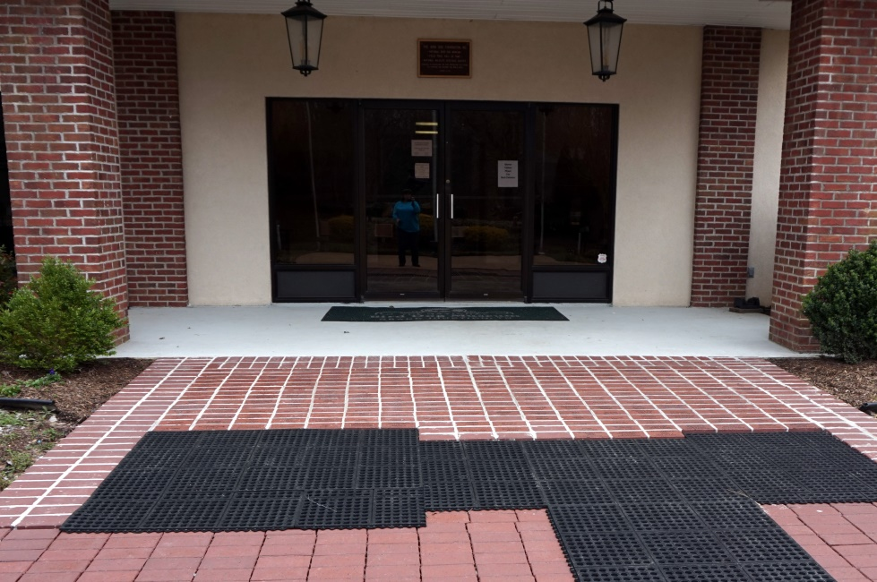

**PAVING MEMORY LANE**

**ORDER FORM**

National Bird Dog Museum

This is the only order form approved to order Engraved Brick.

731-764-2058

Laser Engraved Brick Order Form Customer Information

Customer Name _______________________________________________________

Phone Number ________________________________________________________

Address ______________________________________________________________

City __________________________________________________________________

Zip _______________ email ______________________________________________

***“Brittany Fund”***

The cost of the bricks will be $100.00 each. You are allowed 3 rows of 15 characters in lower case or 14 characters in upper case.

|  |  |  |  |  |  |  |  |  |  |  |  |  |  |  |
| --- | --- | --- | --- | --- | --- | --- | --- | --- | --- | --- | --- | --- | --- | --- |
| Line  1 |  |  |  |  |  |  |  |  |  |  |  |  |  |  |
| Line  2 |  |  |  |  |  |  |  |  |  |  |  |  |  |  |
| Line  3 |  |  |  |  |  |  |  |  |  |  |  |  |  |  |
|  |  |  |  |  |  |  |  |  |  |  |  |  |  |  |

**List of Brick Names (2-18-20)**

6xCh, 1xRU-Ch Joker’s Jackpot Steve & Lori Ralph

6xCh, 6xRU-Ch Smarteyes-Joker Steve & Lori Ralph

Aaron Allard

A.H. Aby

Alamucky Valley Warrior (s/b ‘Alamuchy’)

Alamo Brittany Club

Alan R Stuyvesant

Amedeo Ori MH Ami 1995-2008

Amedeo’s Harry Two-B Harry 1996-2011

Amer.Fld.Ch DC/AFC J&M Ace High Jax

Amer.Fld.Ch DC/AFC J&M Jax Sugar Babe

Andy Gomez

Anne Parchman

Anthracite Brittany Club NE-PA Est. 1973

Bazooka’s Brandy

B.F. Dutch Epperson

Boudreaux Victor Hunter David and Darlene Dow

Bill Norvell

Birch Hill Brittanys Bob-Leslie Fleury

Bob Iversen

Bob & Mary McAuslin Mary Mc

Brandy’s Bullet

Brittany Field Trial Hall of Fame Association

Buddington Prince

C.E. Griffith

California Brittany Club 2019

Central New Mexico Brittany Club

CH AFC Wildwood Tennessee Chip Dick and Carol Pulliam

CH Birchwoods Coco SH Coco 1994-2008

Champion Centerville’s Whim

Chester Varner

Cisco Ori Cisco 2000-2015

Clem Little & Tia

Credit Brittanys Jessie Schulz

Dan Huddleston

Darrell Gaynor HiSpirit Brittanys

Dave & Carol Fletcher Printing

DC Amber Ridge Sir Lancelot

DC Birchwoods In The Nik of Time Nicki 1999-2015

DC/AFC Grand Junction Jake Dick & Carol Pulliam

DC/AFC Hope’s Maximilien Robespierre

DC AFC St Joseph Ori Joey 203-2015

DC/AFC Sts Abracadabra of Jolaine MHCD 1st Brittany MH

DC/AFC Wayside’s Blue

Delmar Smith

Diamond Hill Brittanys

Diana & Gary Kubitz

Dr. John & Judy Webb

Dr. Walker Heap

Dr. Tim

Dualite Brittanies Bob & Karen Oppie

E.B. Bud Epperson

Farout Mary Dierberg

Francis Clasen

Frank Hanwright

Frank Hanwright

Fred Adams

Fred Brooks

Fred Warrior-71

Gandy Dancer JH Gandy Ori 1998-2014

Grand Junction Buck Dick and Carol Pulliam

Gringo

Henry Wierzbicki Sheila Cordner

Hi Proof Rum Runner

Hi Spirit Bazooka’s Pistol

Holliday Britt

Holliday Britt’s Bazooka

H.R. and Sally Gentsch KarKar Brittanys

In Memory of Bill Tiedeman Nebr. Brittany

In memory of Dean Taylor Nebr. Brittany

In Memory of Greg Bailey Nebr. Britany

In Memory of Jack Hires WMBC

In Memory of Jeanne Telfare WMBC

In Memory of John Poland NE Britt Champ

In Memory of Randy Mille , Nebr. Brittany

In Memory of Velma Tiedeman Nebr. Brittany

J&M Brittanys Jim & Mary Crawford

Jack Huffman Wellston OH

Jacolet’s Wandering Star

James & Betty Doherty

James & Marcelle Bell

Jim & Janet Chase

Jim & Mary Crawford

Jim & Mary Crawford

Jim & Mary Crawford

John & Ann Doak

John & Betty Evans Phillipsburg, MO

Joyce & Dave Lincoln

Joyce and Dave Lincoln

Judy & Tom Robin Annie & We-Be

Kent Patterson

Ken Jacobson

Lane’s End Bowtie Annie

LBC 2017 Mary C Seines Lifetime Award

LBC 2018 Colleen Walsh Lifetime Award

Leon Milligan

Lisa & Paul Pollock

Lloyd Miller, Jockey Hollow FTC

Londa Warren AFC Jazzy O’Shillelagh

Louis A Thebaud

Loving Memory Red Cassidy 10/27/2018

Marge & Lyle Johnson

Marilynne Little & Chik

Mary Karbiner & Loyd Budd

Michigan Brittany Club

Midwest Brittany

Mike Godin

Ms. Barbara Rokas

MTB Brittanys Tom & Margaret White

My Mentor Leslie Like

NAC DC AFC 1xCH Renegade’s Kansas Kid

NAFC Missouri Brittany Club Coke Ginger Sparky

Nancy Clendenen

Nebraska Brittany Club

New England Brittany Championship Assoc.

NFC Missouri Brittany Club Ban-Dee Bernie Shadow

Pacolet Cheyenne Sam

Paul & Lisa Pollock

Perry’s Rustic Prince

Pete Dixon

Poki Dot Meam and Jim Floyd

Raven Cali Billie JJ Sera David and Darlene Dow

Reidy Hills Brittanys

Rene Ramirez

Rex & Tonya Brotherton

Rheta & Bill Cartmell

Richard & Carol Pulliam

Rick Smith

Ringo De Britt

RIP & Bob the squirrel dog David and Darlene Dow

Robert & Leslie Fleury

Robert Richter Rob RC’s Sundancer Rudy

Ronnie Smith Jr.

Ronnie Smith Sr

Saradac Britts Since 1965 Edward W Kostka Senior & Junior

Scipio Spinks

Senator TJ

Shirley Chilcote

Skydancer MH 2-B Ori 1997-2012

Sno Fun Mac

Sooner Brittany Club

Southern Kansas Brittany Club 2017 60 years

Southern New England Britany Club

Sparky Shadow

Sparky Shadow Lincoln

Stanley Truksa Claudia Truksa Nebraska Brittany Club

St Amadeo Ori Ami DOB 2008

St Croix Valley Brittany Club

St Louis Ori LuLu DOB 2007

St Nicholas Ori Niki DOB 2007

St Sage Ori Sage DOB 2008

Terry Carter

Texas Coastal Brittany Club

Texas Coastal Brittany Club

Tigars Jocko John Munson

Tom & Gretchen Burroughs

Tom Black

Tom Burroughs Smoke Zing Sparks Tut Zip Shane

Tom Burroughs Upland Acres Champion Britts 2DC 4FC 4AFC

Tom Crater

Tom Longfellow

Tom Smith

Towsey

T.Swierczynski Hellgate Kennels

United States Open Brittany Championship

Walter Kleeman

Wanbli 5xCh/2xRUCh O/H Kenny DeLong

Way-Kan Jill

Wayne Carter

William Bill Ryker

Willis Corbett A Foundation Patron

Willo Barfield

Willo Barfield

Windswept’s Clay Bullet Gary Ramsey